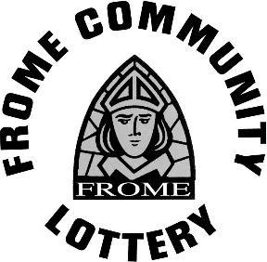

FROME COMMUNITY LOTTERY GRANT APPLICATION FORM 2024
(closing date 28th March 2024)﻿

Organisation’s Name
Full Name of Contact Person
Contact Person Email
Contact Person Telephone
Organisation’s Registered Address
Organisation’s Registered Status
If a Charity, please provide registered charity number
Please briefly describe the aims and objectives of your organisation (max. 300 words)
Please outline the organisational structure and size (employed and/or voluntary staff) of your organisation (max. 300 words)
To be eligible for Frome Community Lottery funding your project must meet ALL of the following criteria.
- The funding is to be spent to benefit all or part of the community in the designated geographical area of Frome and surrounds.
- The funding is for capital expenditure (not general running costs, wages, consumables, maintenance, etc).
- The funding is not for the exclusive benefit of an individual person, family or household.
- The funding is for a specific purpose which improves an existing or develops a new community facility.
- The project funded is not divisive or controversial in the local community.
- The funding does not take the place of government or other statutory funding.
Describe the project for which you require funding (max. 800 words)
How much have you raised so far (including pledges of money not yet actually received)?
How much are you requesting for your project from the Frome Community Lottery and how have you arrived at this figure?
Please give details of how else you are seeking funding for your project (max. 300 words)
Please give details of how your project will impact the local community, and how you will measure this? (max. 300 words)
Please sign to confirm you understand each of the following expectations of those who receive funding from Frome Community Lottery (FCL).
I confirm that the information given in this application is accurate and that any funds awarded will be used for the purposes stated.

